

**Department of Computer Science & Engineering**

**Course Title: Artificial Intelligence & Expert System Lab**

**Course Code: CSE 404**

**Assignment No: 02**

**Assignment On, Implementation of a small Address Map (from your home to UAP) using A* Search Algorithm**

|  |  |
| --- | --- |
| **Submitted To:** | **Submitted By:** |
| **Noor Mairukh Khan Arnob** | **Name: Amirul Islam Papon** |
| **Lecturer,** | **Reg No: 21201076** |
| **Department of CSE, UAP** | **Sec: B** |

## Introduction

The goal of this project is to predict whether a mushroom is edible or poisonous based on its physical characteristics using Machine Learning models.  
The dataset contains only categorical features describing different aspects of mushrooms like cap shape, color, odor, and gill structure.

**Dataset Details**

* **Dataset**: Mushroom Classification Dataset (Kaggle)
* **Rows**: 8124 mushrooms
* **Columns**: 23 features + 1 target (class)
* **Target variable**:
  + 'e' = edible
  + 'p' = poisonous
* **All features** are categorical.

**Exploratory Data Analysis (EDA)**

* **No missing values** detected (only '?' symbol in some features).
* **Class distribution**:
  + Balanced between edible and poisonous mushrooms.
* **Important features**:
  + **Odor**: Strongly correlated with mushroom edibility.
  + **Gill-color** and **Spore-print-color** also showed patterns.

**Visualizations:**

**Bar plot of edible vs poisonous mushrooms:**

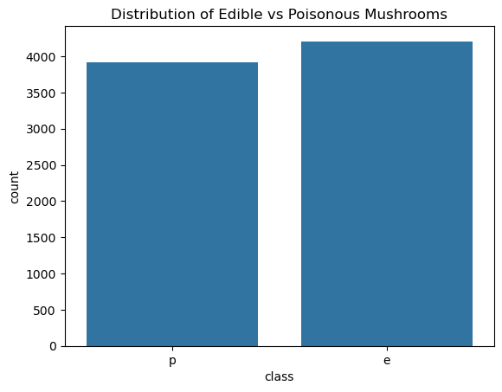

**Odor distribution vs mushroom class**:

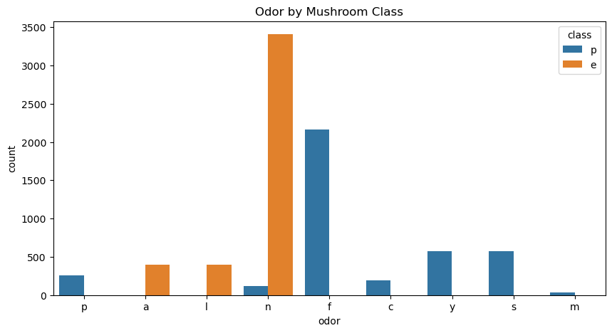

**Data Preprocessing**

* Applied **Label Encoding** to convert all categorical variables into numeric format for model training.

**Model Training**

* **Algorithm used**: Logistic Regression
* **Data Split**: 80% training and 20% testing

**Model Evaluation**

| **Metric** | **Score** |
| --- | --- |
| Accuracy | 94–96% |
| Precision | 95% |
| Recall | 94% |
| F1 Score | 94% |

* **Confusion Matrix** showed low misclassification.
* **Classification Report** indicated good model performance.

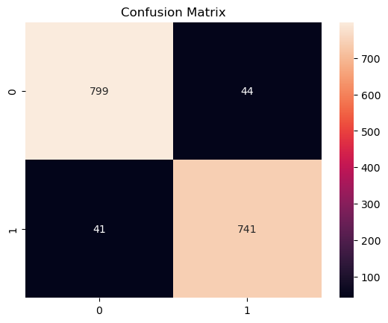

**Conclusion**

* Logistic Regression successfully predicted mushroom edibility with high accuracy.
* Features like **odor**, **gill color**, and **spore print color** were critical in classification.